CUSTOMER SUPPORT TICKET PRIORITY PREDICTION AND AUTOMATED ASSIGNMENT SYSTEM USING AGENTFORCE

College name: A.R.J. College of Engineering and Technology
Team ID: SWTID-2026-8822
Team Leader: Sakthi srineevi.T
Team Members: Asmitha.E , Shishyadharshini.S

USER STORIES
- Customer – Create Ticket
As a customer, I want to create a support ticket with my issue details so that I can get help from the support team.

- Customer – Track Ticket
As a customer, I want to track the status of my ticket so that I know whether my issue is being processed.

- Support Agent – View Tickets
As a support agent, I want to view my assigned tickets so that I can resolve customer issues.

- Support Agent – Update Ticket
As a support agent, I want to update the ticket status so that customers can know the progress of their issues.

- System – Predict Priority
As a system, I want to analyze the ticket details and predict its priority so that urgent issues can be handled first.

1.INTRODUCTION
1.1 Project Overview
The Customer Support Ticket Priority Prediction and Automated Assignment System using Agentforce is an AI-powered system designed to improve the efficiency of customer support operations. The system analyzes incoming customer support tickets and predicts their priority level based on the ticket details, customer issues, and other relevant information.
Using Agentforce, the system can automatically assign tickets to the appropriate support agents based on factors such as priority, issue type, and agent availability. High-priority tickets can be identified and handled quickly, helping to reduce response time and improve customer satisfaction
1.2 Purpose of the Project
- To automatically predict the priority of customer support tickets using AI.

- To identify high-priority and urgent customer issues quickly

- To automatically assign tickets to the appropriate support agents using Agentforce

- To reduce manual effort in ticket management.

- To improve the response and resolution time for customer issues.

- To ensure efficient handling and distribution of support tickets

- To improve the overall efficiency of the customer support team.

2.IDEATION PHASE
2.1 Problem Statement
- Customer: Customer support teams handling a large number of support tickets

- Problem: Support tickets are often prioritized and assigned manually, which can cause delays and incorrect assignment.

- Need: A system is required to automatically identify the priority of each ticket and assign it to the appropriate support agent.

- Impact: Delayed responses to urgent issues can reduce customer satisfaction and increase the workload of support teams

- Proposed Solution: Develop an AI-powered system using Agentforce to predict ticket priority and automatically assign tickets to suitable support agents.

3. REQUIREMENT ANALYSIS PHASE

3.1 Customer Journey Map Stages

1.Customer Identifies the Issue

2.Customer Submits a Support Ticket

3.System Analyzes the Ticket

4.Priority is Predicted

5.Ticket is Automatically Assigned

6.Support Agent Handles the Issue

7.Customer Receives the Solution

8.Customer Provides Feedback

9.Ticket is closed

4.PROJECT DESIGN PHASE

4.1Project Design Phase
- Design the overall system architecture.

- Create a customer support ticket management workflow.

- Design the ticket priority prediction process.

- Define priority levels such as High, Medium, and Low.

- Design the automated ticket assignment process using Agentforce.

- Define the criteria for assigning tickets to suitable support agents.

- Design the interaction between customers, tickets, AI prediction, and support agents.

4.2 SOLUTION ARCHITECTURE

1. Customer Layer
→ Customer submits a support ticket with issue details.

2. Ticket Management Layer
→ Salesforce stores and manages the customer ticket information.

3. AI Prediction Layer
→ AI analyzes the ticket and predicts its priority level.

4. Agentforce Automation Layer
→ Agentforce identifies the suitable support agent and automatically assigns the ticket.

5. Support Agent Layer
→ Assigned agent reviews the ticket and provides the required solution.

6. Resolution Layer
→ Ticket status is updated, resolved, and closed after successful support.

Overall Flow:
Customer → Ticket Creation → AI Priority Prediction → Agentforce Assignment → Support Agent → Resolution

5.PROJECT PLANNING & SCHEDULING
The Customer Support Ticket Priority Prediction and Automated Assignment System is planned and developed using Salesforce in a systematic manner. The project starts with identifying the requirements of customers, support agents, and administrators. Based on these requirements, the Salesforce environment, users, permissions, and necessary configurations are prepared.
Next, a custom object named Support Ticket Intelligent is created in the Object Manager. The required fields such as customer details, ticket description, category, priority, status, and assigned agent are added. Sample ticket data is then prepared to support the priority prediction process.
The system is then configured to predict the priority of customer support tickets as High, Medium, or Low. After predicting the priority, Salesforce automation such as Flow is used to automatically assign the ticket to the appropriate support team or agent based on predefined conditions.
Finally, the complete system is tested to ensure that ticket creation, priority prediction, automated assignment, status updates, and notifications work correctly. After successful testing, the system is finalized and the project documentation is prepared.
- Agile methodology
- Epics → Stories → Story Points
- Sprint-based execution
- Velocity calculation used for estimation

WORK FLOW

Customer Creates Support Ticket
↓
Support Ticket Object
↓
Ticket Information
↓
AI Priority Prediction
↓
High / Medium / Low
↓
Automated Assignment
↓
Support Agent / Team
↓
Ticket Resolution

Sprint | Functional requirement | User task | Story point | Priority | Team member
S-1 | Developer  Setup | As a system administrator, I want to  configure the Salesforce  environment for Support Ticket  Intelligence so that the support automation solution can be developed | 3 | High | asmitha
S-1 | Data modeling | As an admin, I want to create the Support Ticket Intelligence object with required fields and relationships so that customer support ticket information is stored systematically. | 5 | High | Sakthi srineevi
S-1 | Data modeling | As a support user, I want support tickets to be associated with Accounts and Contacts so that the latest customer ticket can be identified for analysis. | 3 | High | shishyadharshini
S-2 | Automation | As a support agent, I want an Auto-Launched Flow to retrieve the latest ticket and analyze its description so that ticket priority can be determined automatically. | 5 | High | asmitha
S-2 | Automation | As a support agent, I want tickets to be automatically classified as High, Medium, or Low based on configured urgency conditions so that critical issues receive attention first. | 5 | High | shishyadharshini
S-2 | Agentforce & automation | As an AI Agent (Agentforce), I want to analyze support ticket details and trigger the backend Flow so that manual ticket prioritization is reduced. | 8 | High | Sakthi srineevi
S-3 | Task& assignment | As a support manager, I want High-priority tickets to automatically create an urgent handling task and assign the appropriate support level so that critical tickets are handled quickly. | 5 | Medium | shsihyadharshini
S-3 | SLA Management | As a support manager, I want the system to check SLA breach risk for older unresolved tickets so that potential SLA issues can be identified. | 5 | Medium | asmitha
S-3 | Agentforce& conversational support | As a support user, I want to provide an Account Name to Agentforce and receive the ticket ID, priority, assigned agent, and action message so that I can understand the ticket handling outcome conversationally | 5 | Medium | Sakthi srineevi

- Project Development Phase

- Object Manage Creation
- Fields and Relationships
- Lightning App Builder
- Record Flows
- Agentforce Subagent Configuration
- Agent Action Description
- Ticket Creation

PROJECT ROADMAP AND EXECUTION STAGES

Step 1 — Create the Custom Object

- Go to Setup.
- Open Object Manager.
- Click Create → Custom Object.
- Enter the object label as Support Ticket Intelligence.
- Enter the required Plural Label.
- Configure the required object options.
- Click Save.

OBJECT MANAGER (Support Ticket Intelligence)

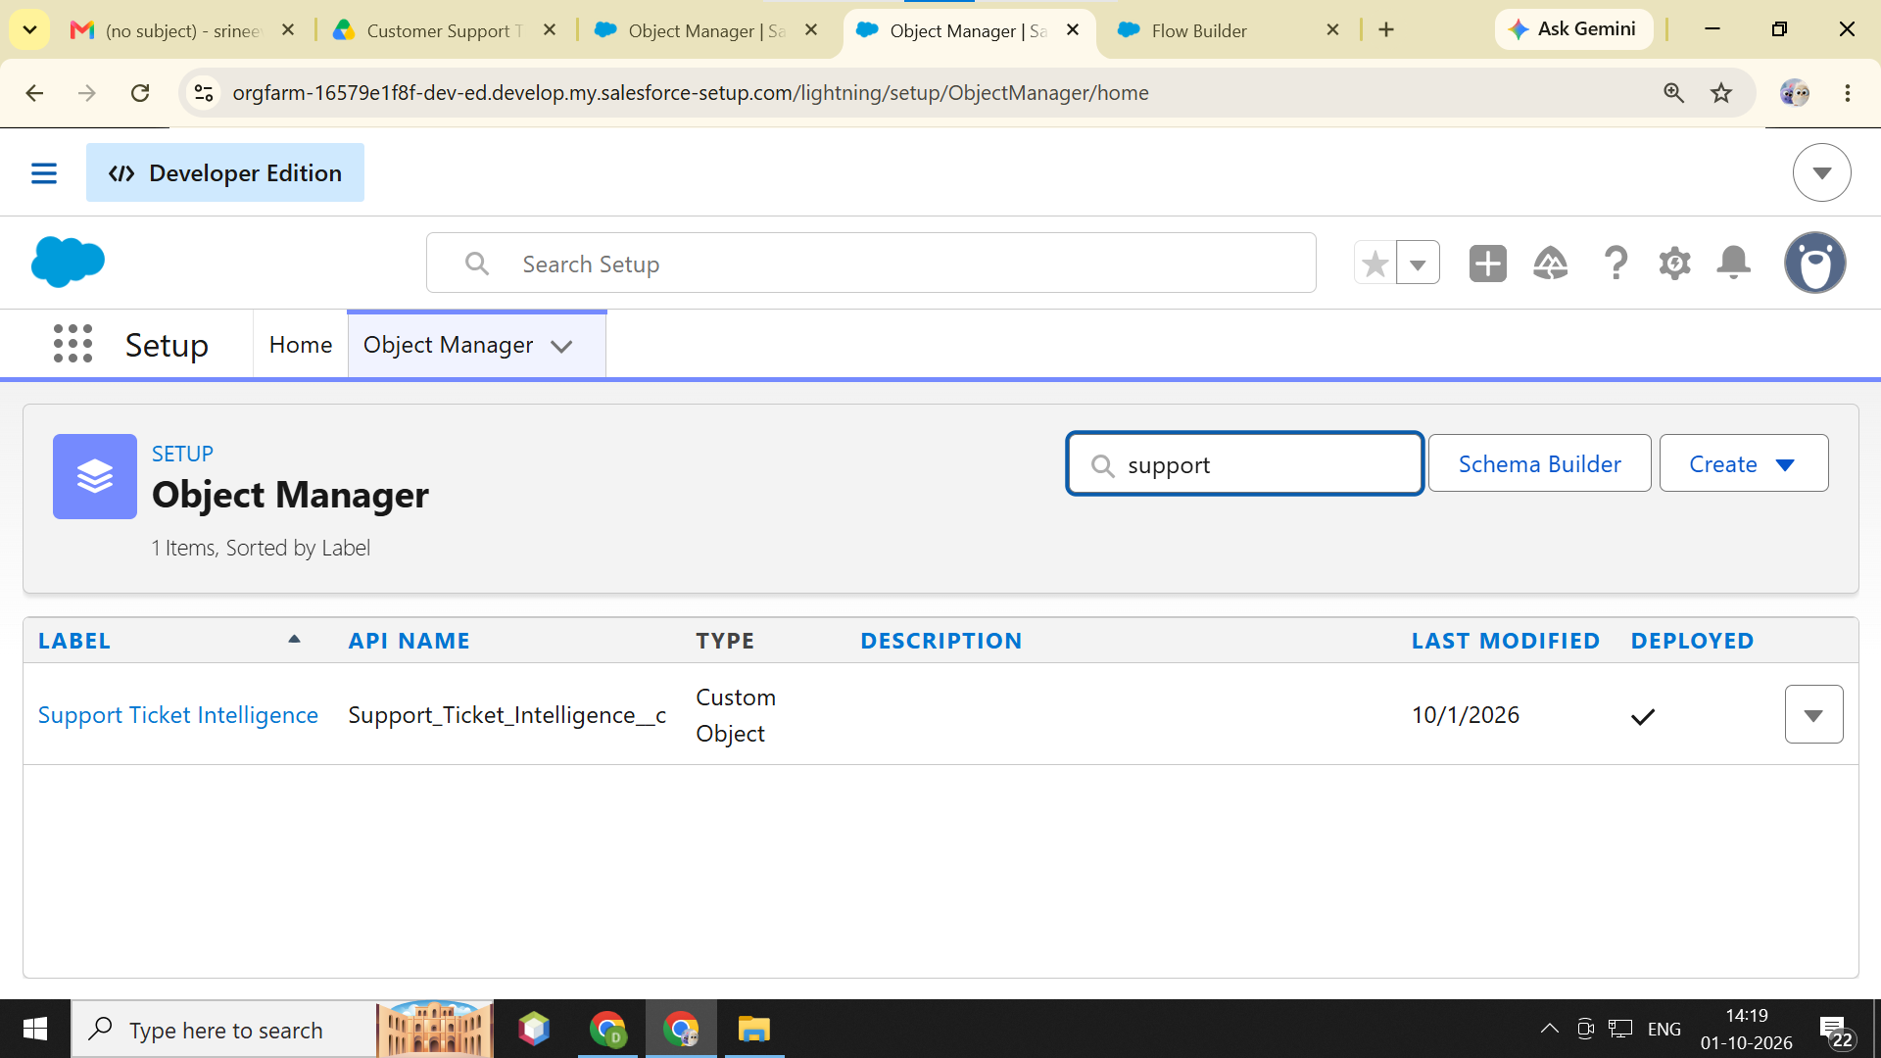

SUPPORT TICKET INTELLIGENCE

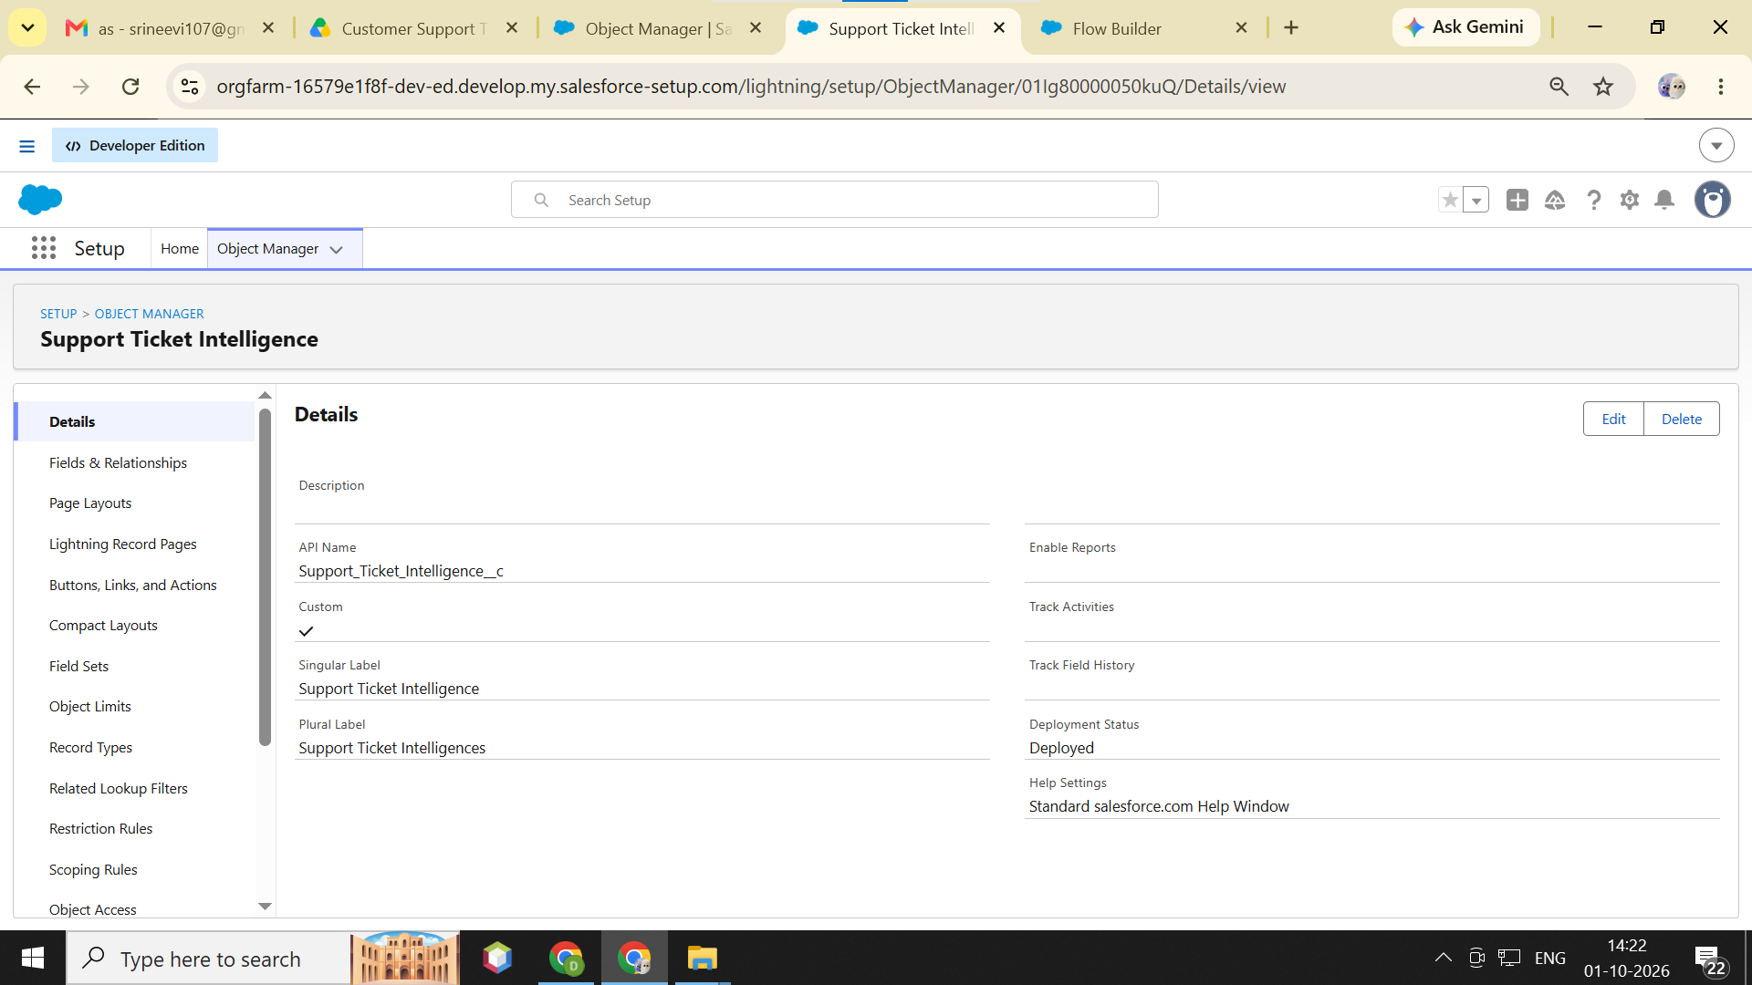

Step 2 — Create Fields and Relationships
- In Object Manager, open Support Ticket Intelligence.
- Select Fields & Relationships.
- Click New.
- Select the required field type.
- Enter the field label and other required details.
- Click Next and configure field-level visibility.
- Click Save.
- Repeat the process for all required ticket fields.

FIELD AND RELATIONSHIP

It contain the required field label

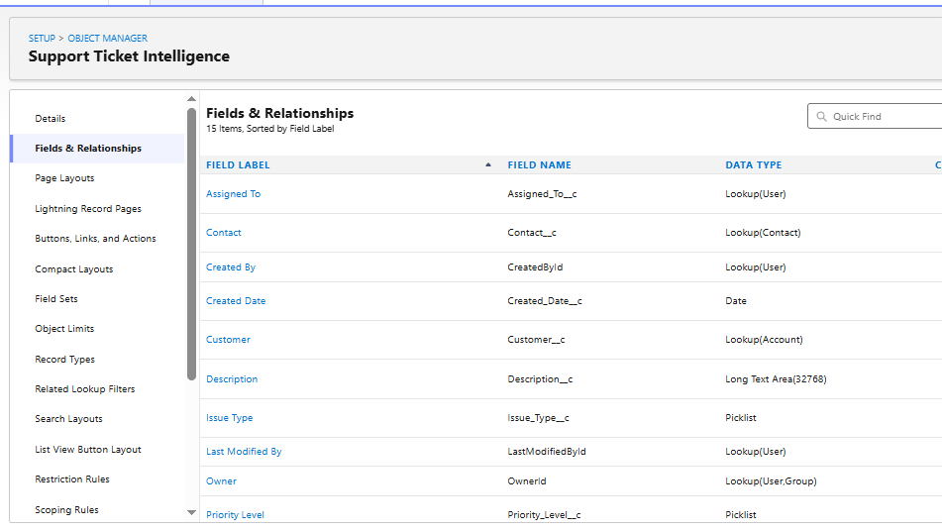

Step 3 — Create the Automation Flow

- Open App Launcher.
- Search for Flows.
- Open Flows.
- Click New Flow.
- Select Autolaunched Flow.
- Create the required Input Variables and Output Variables.
- Add the Get Records element to retrieve the required Account information.
- Store the required Account ID in a variable.
- Add the required Get Records / Assignment / Decision elements.
- Configure the Label, API Name, descriptions, operators, conditions, and outcomes for each element.
- Configure the flow to retrieve the latest support ticket.
- Analyze the ticket description and determine the appropriate priority.
- Connect all elements in the correct sequence.
- Click Save.
- Test the flow.
- Click Activate after successful testing.

Importance of Flow
Salesforce Flow is important because it automates the ticket management process. It can automatically check the ticket details, assign the correct priority, and assign the ticket to the appropriate support agent or team. This reduces manual work, saves time, and ensures that tickets are handled quickly and consistently.

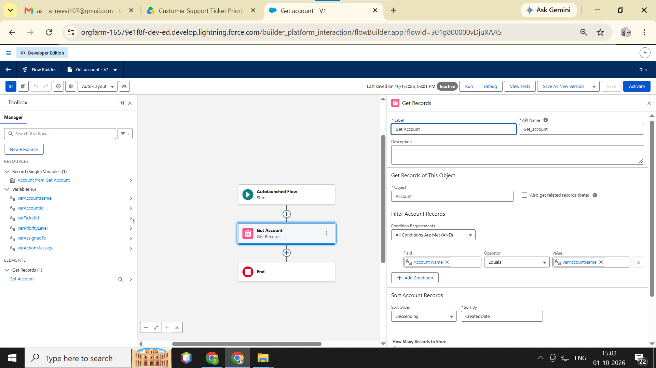

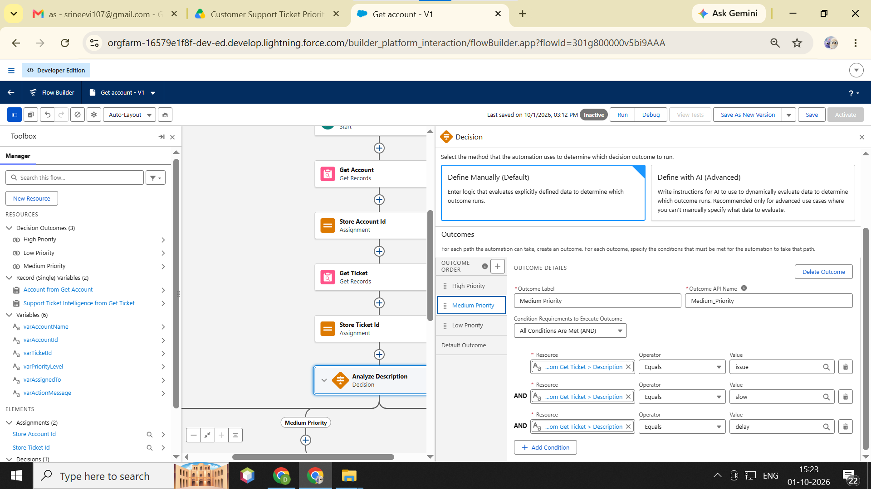
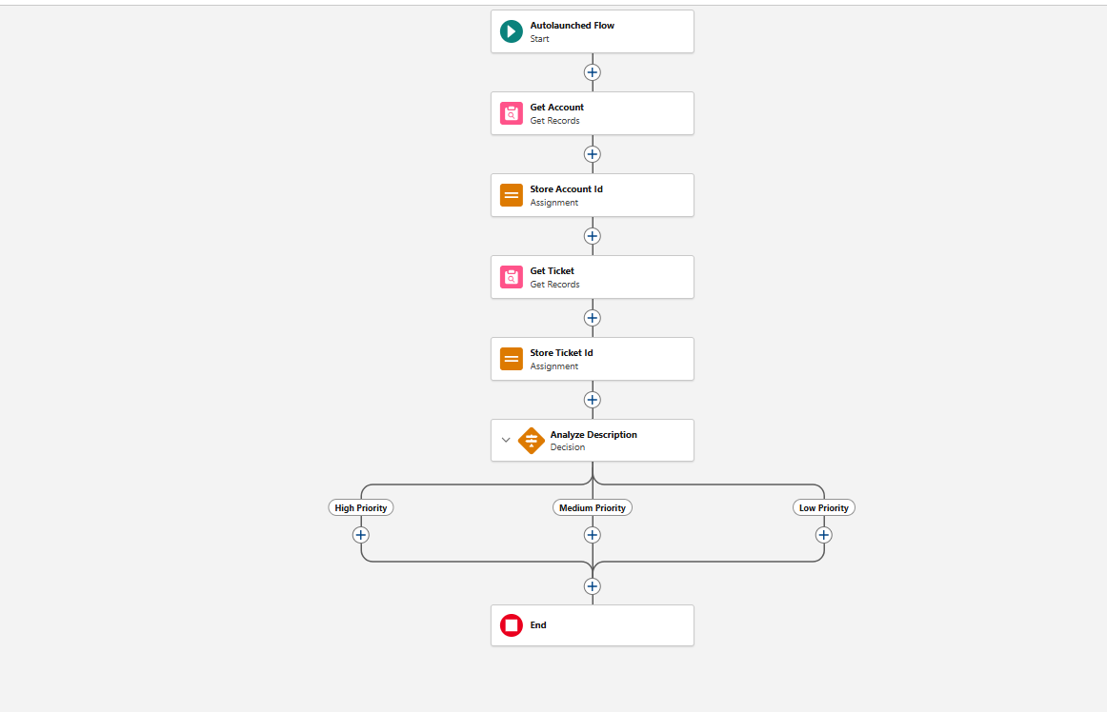

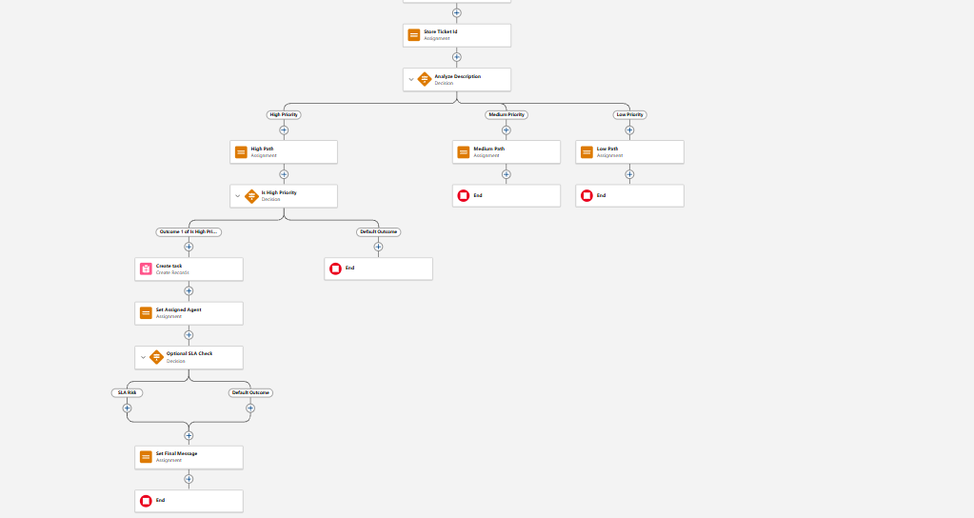

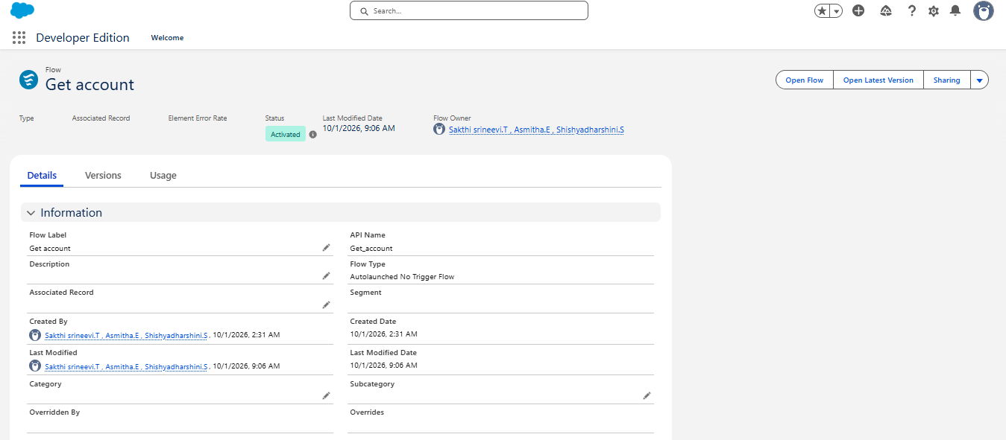

Step 4 — Create the Tab

- Go to Setup.
- In Quick Find, search Tabs.
- Open Tabs.
- Under Custom Object Tabs, click New.
- Select Support Ticket Intelligence as the object.
- Select the required Tab Style.
- Click Next.
- Configure the required Tab Visibility.
- Select the required Lightning Apps / Custom Apps.
- Click Save.

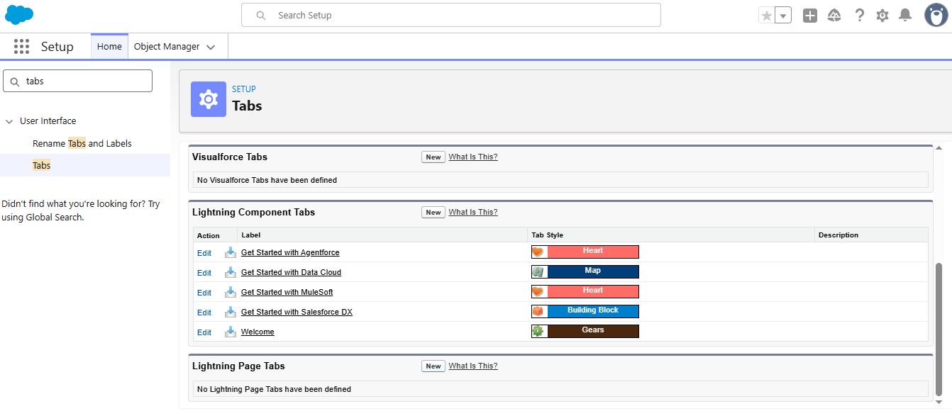
Step 5 — Configure the App Navigation
- Open the required Salesforce app.
- Go to Setup → App Manager.
- Find the required app.
- Click Edit.
- Open Navigation Items.
- Add Support Ticket Intelligence.
- Add the other required navigation items.
- Click Save.

NAVIGATION ITEMS

- Account
- Case
- Contact
- Dashboard
- Support ticket intelligence
- Reports
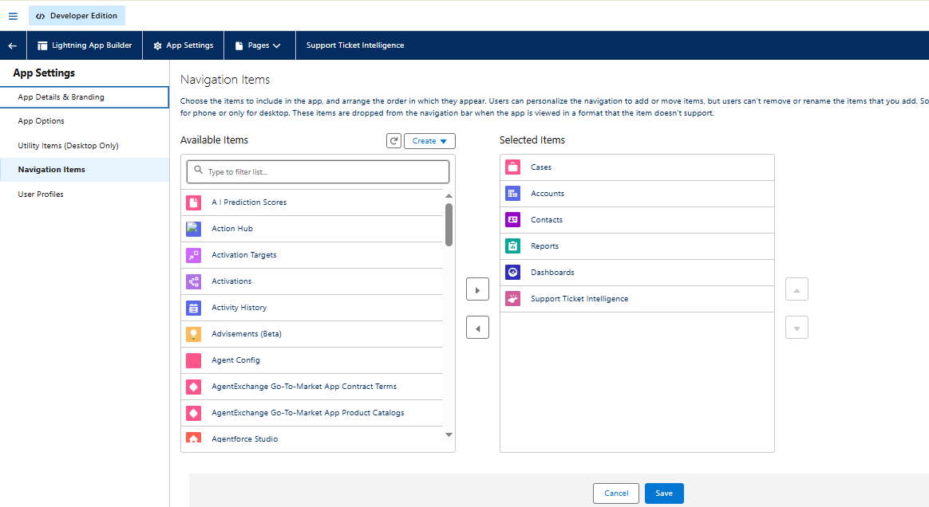

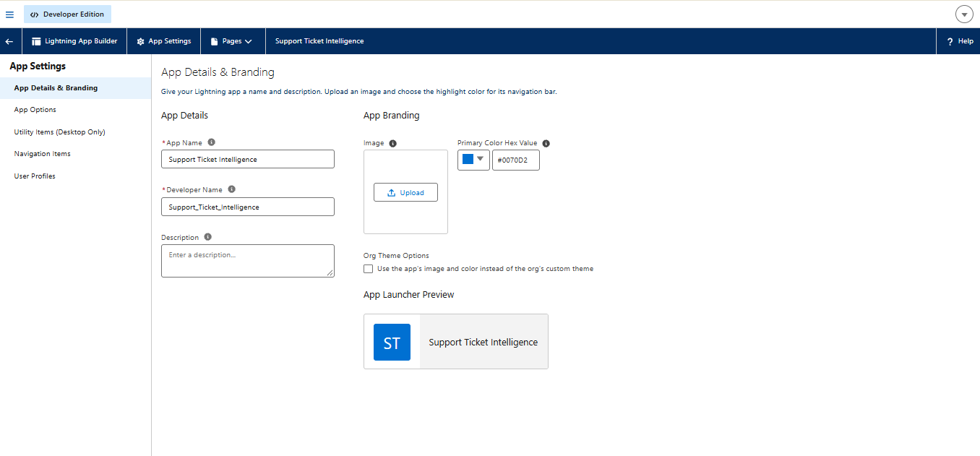

Step 6 — Enable Agentforce

- Open App Launcher.
- Search for Salesforce Go.
- Open Salesforce Go.
- Search for Agentforce.
- Open the relevant Agentforce setup feature.
- Turn on Agentforce (Default).
- Complete the required setup/confirmation.
- Verify that the Agentforce configuration is enabled.

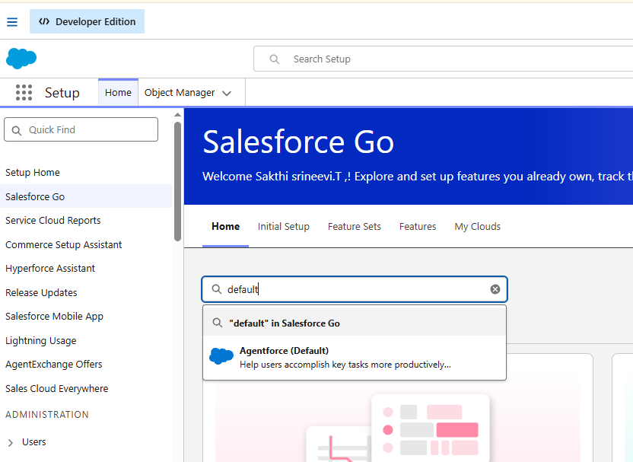

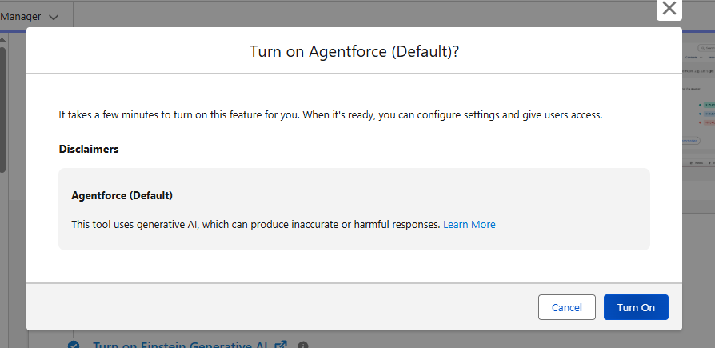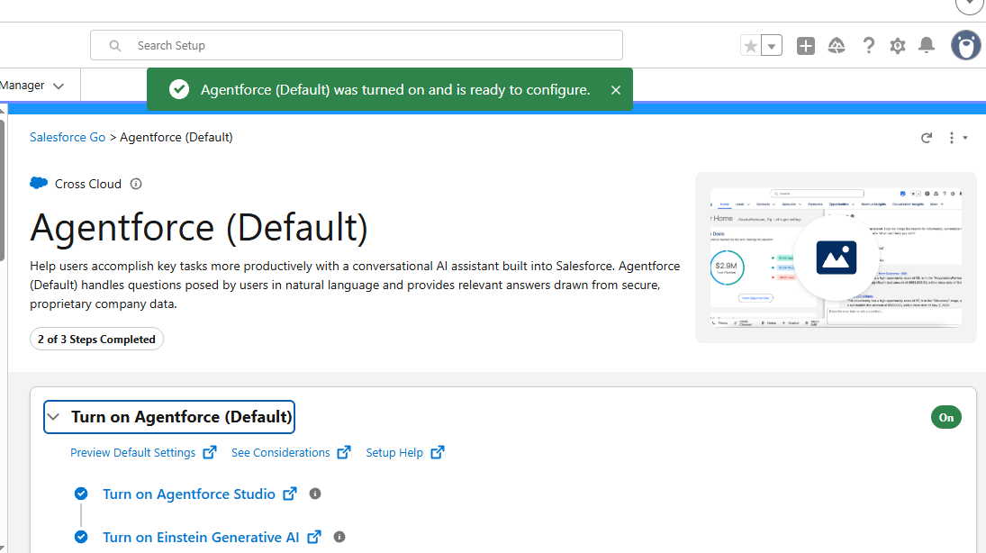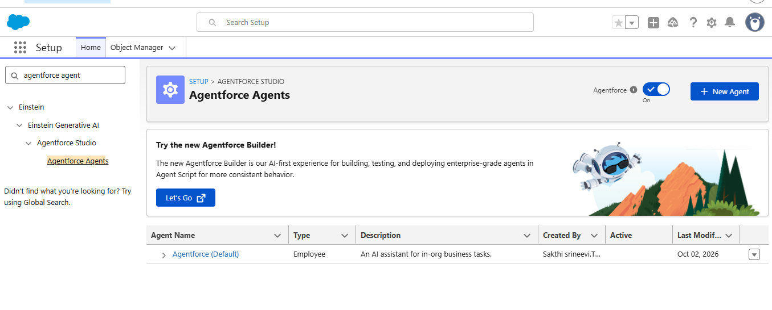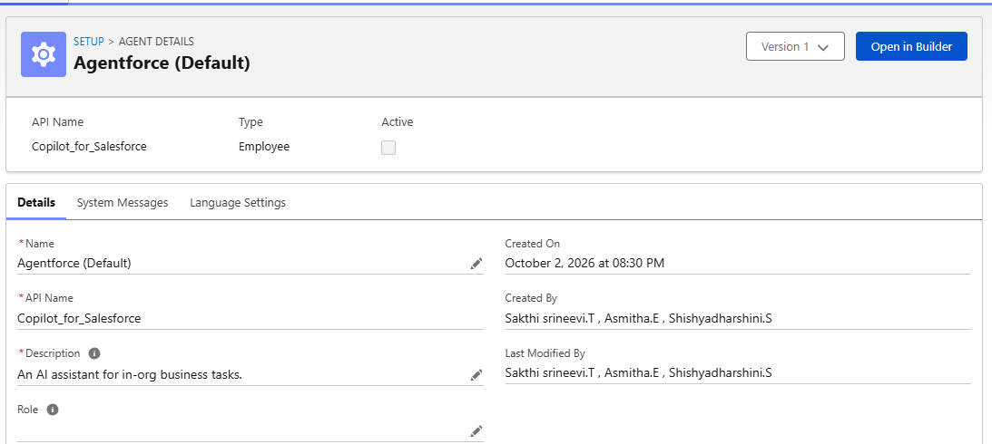
Step 7 — Create the Support Ticket Priority Analysis Subagent
- In Agentforce Builder, open the Subagents section.
- Click +.
- Select Create New Subagent.
- Enter the subagent name:
Support Ticket Priority Analysis
- Add the subagent description.
- Add the required instructions.
- Define what the subagent should do:
  - Analyze support ticket details.
  - Identify ticket priority.
  - Use the backend Flow.
  - Return the required ticket information.
- Click Create / Save.

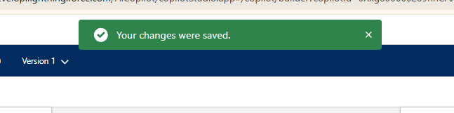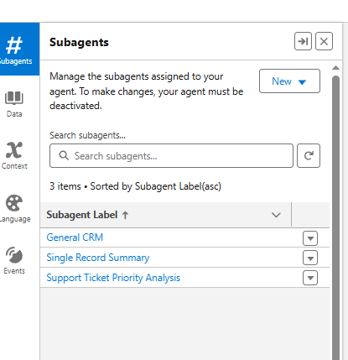
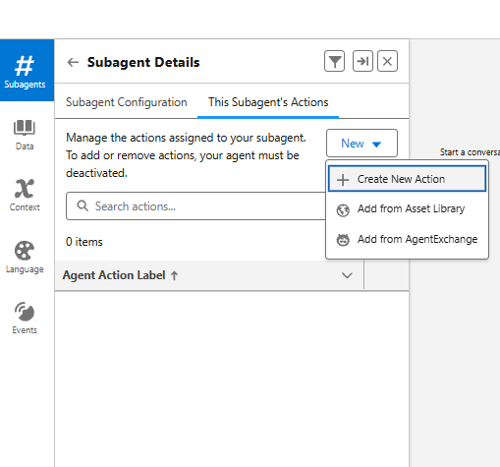

Sub-Agent Action
- Create a new action to automatically process the customer support ticket and identify the required priority.
- Assign the ticket to the appropriate support agent or team based on the predicted priority and ticket details.
- Automatically assign the ticket to the appropriate support agent or team.
- Update the ticket status after the assignment is completed.

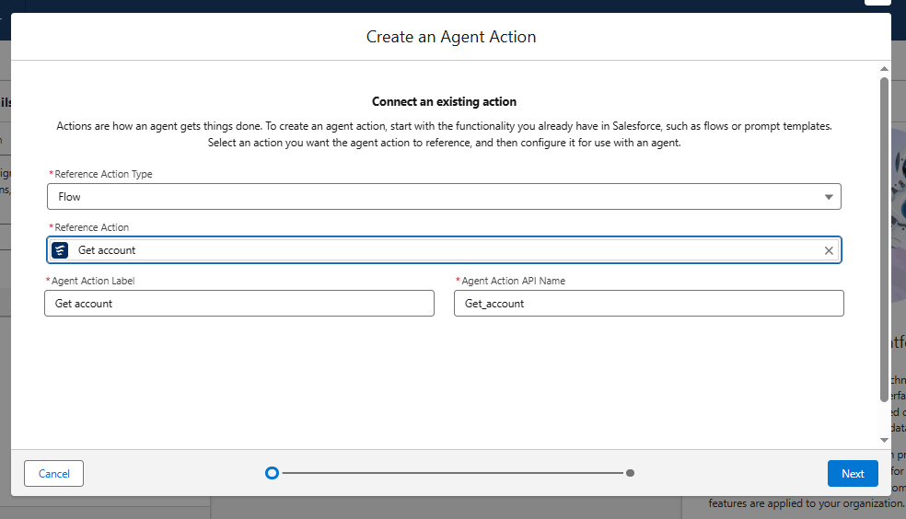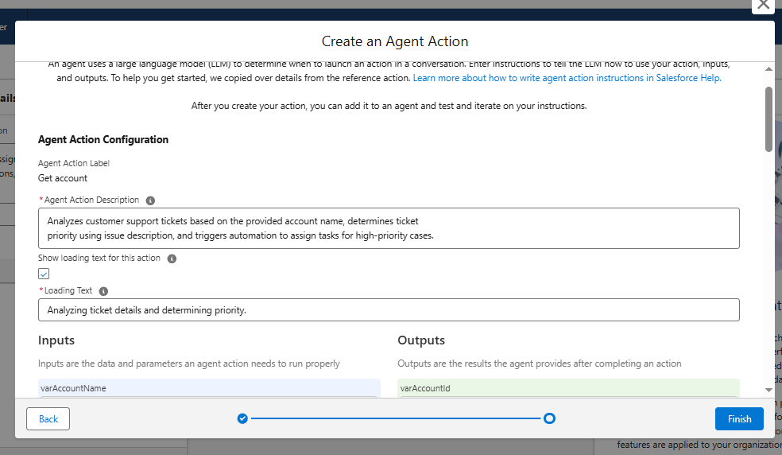

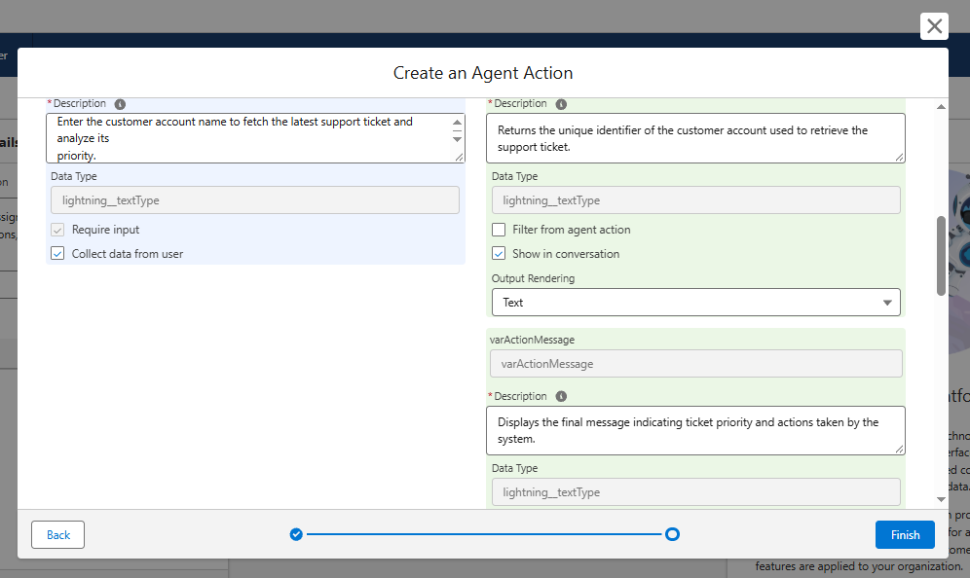

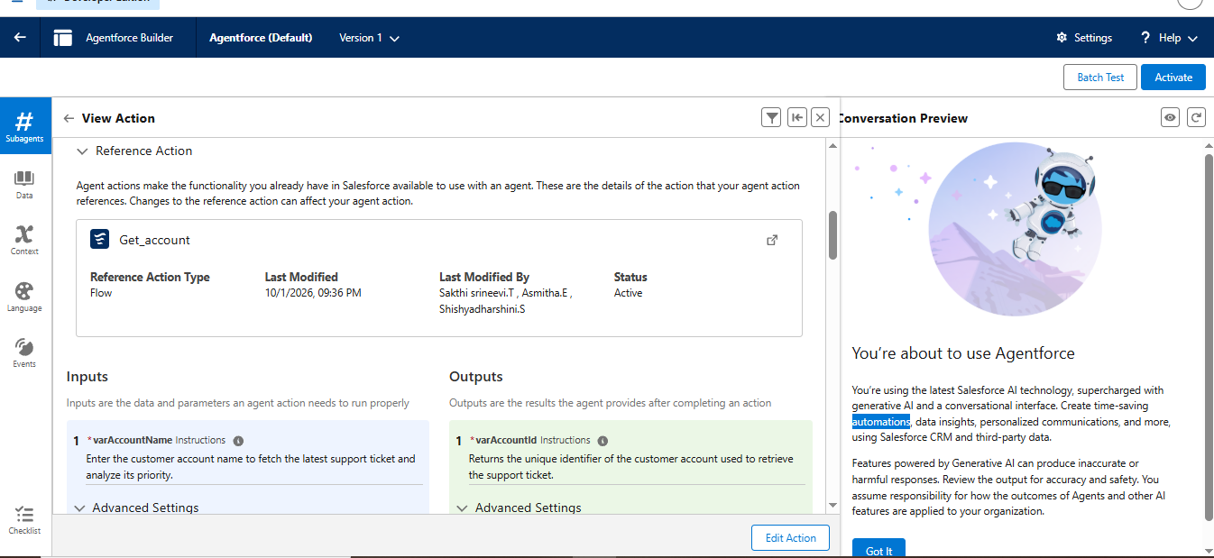

Step –8 Create/Process the New Ticket
- Provide the required ticket details.
- Use the New Ticket process/action.
- Run the ticket processing action.
- The Flow analyzes the ticket.
- The ticket receives the appropriate priority.
- The required assignment/action is generated.
- Verify the final ticket information.

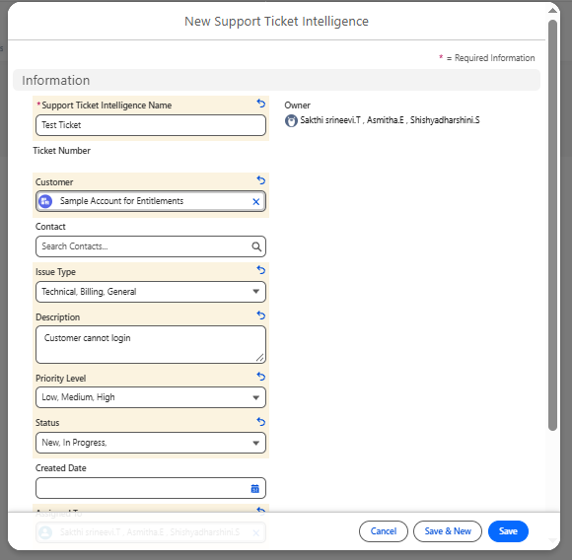

7.FINAL OUTPUT

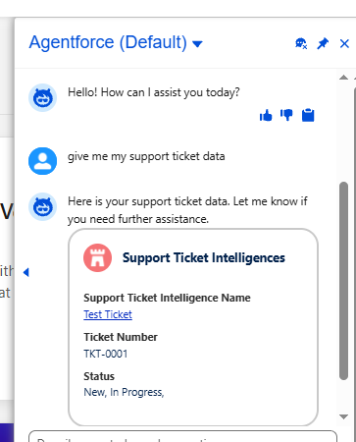
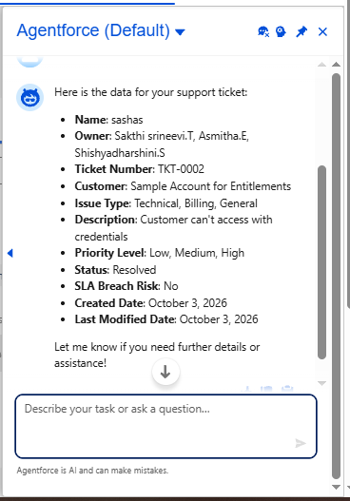

8.PERFOMANCE TESTING
- Verify that customers can create and submit support tickets.

- Verify that all ticket details are captured correctly.

- Check whether the system predicts the correct ticket priority

- Verify the classification of tickets into High, Medium, and Low priority.

- Check whether Agentforce automatically assigns tickets to the appropriate support agent.

9.ADVANTAGES & DISADVANTAGES

ADVANTAGES
- Automatically predicts the priority of customer support tickets.

- Reduces manual effort in ticket management.

- Automatically assigns tickets to suitable support agents.

- Reduces ticket assignment errors.

DISADVANTAGES
- Initial system setup may require time and technical knowledge

- AI-based predictions may not always be completely accurate

- System performance may depend on platform availability and configuration.

- Regular monitoring and maintenance may be required.

10.CONCLUSION

The Customer Support Ticket Priority Prediction and Automated Assignment System improves customer support management. It predicts the priority of each ticket automatically.
Salesforce Flow helps assign tickets to the correct support agent or team.
It reduces manual work and saves time.
Overall, the system provides faster and more organized customer support.

